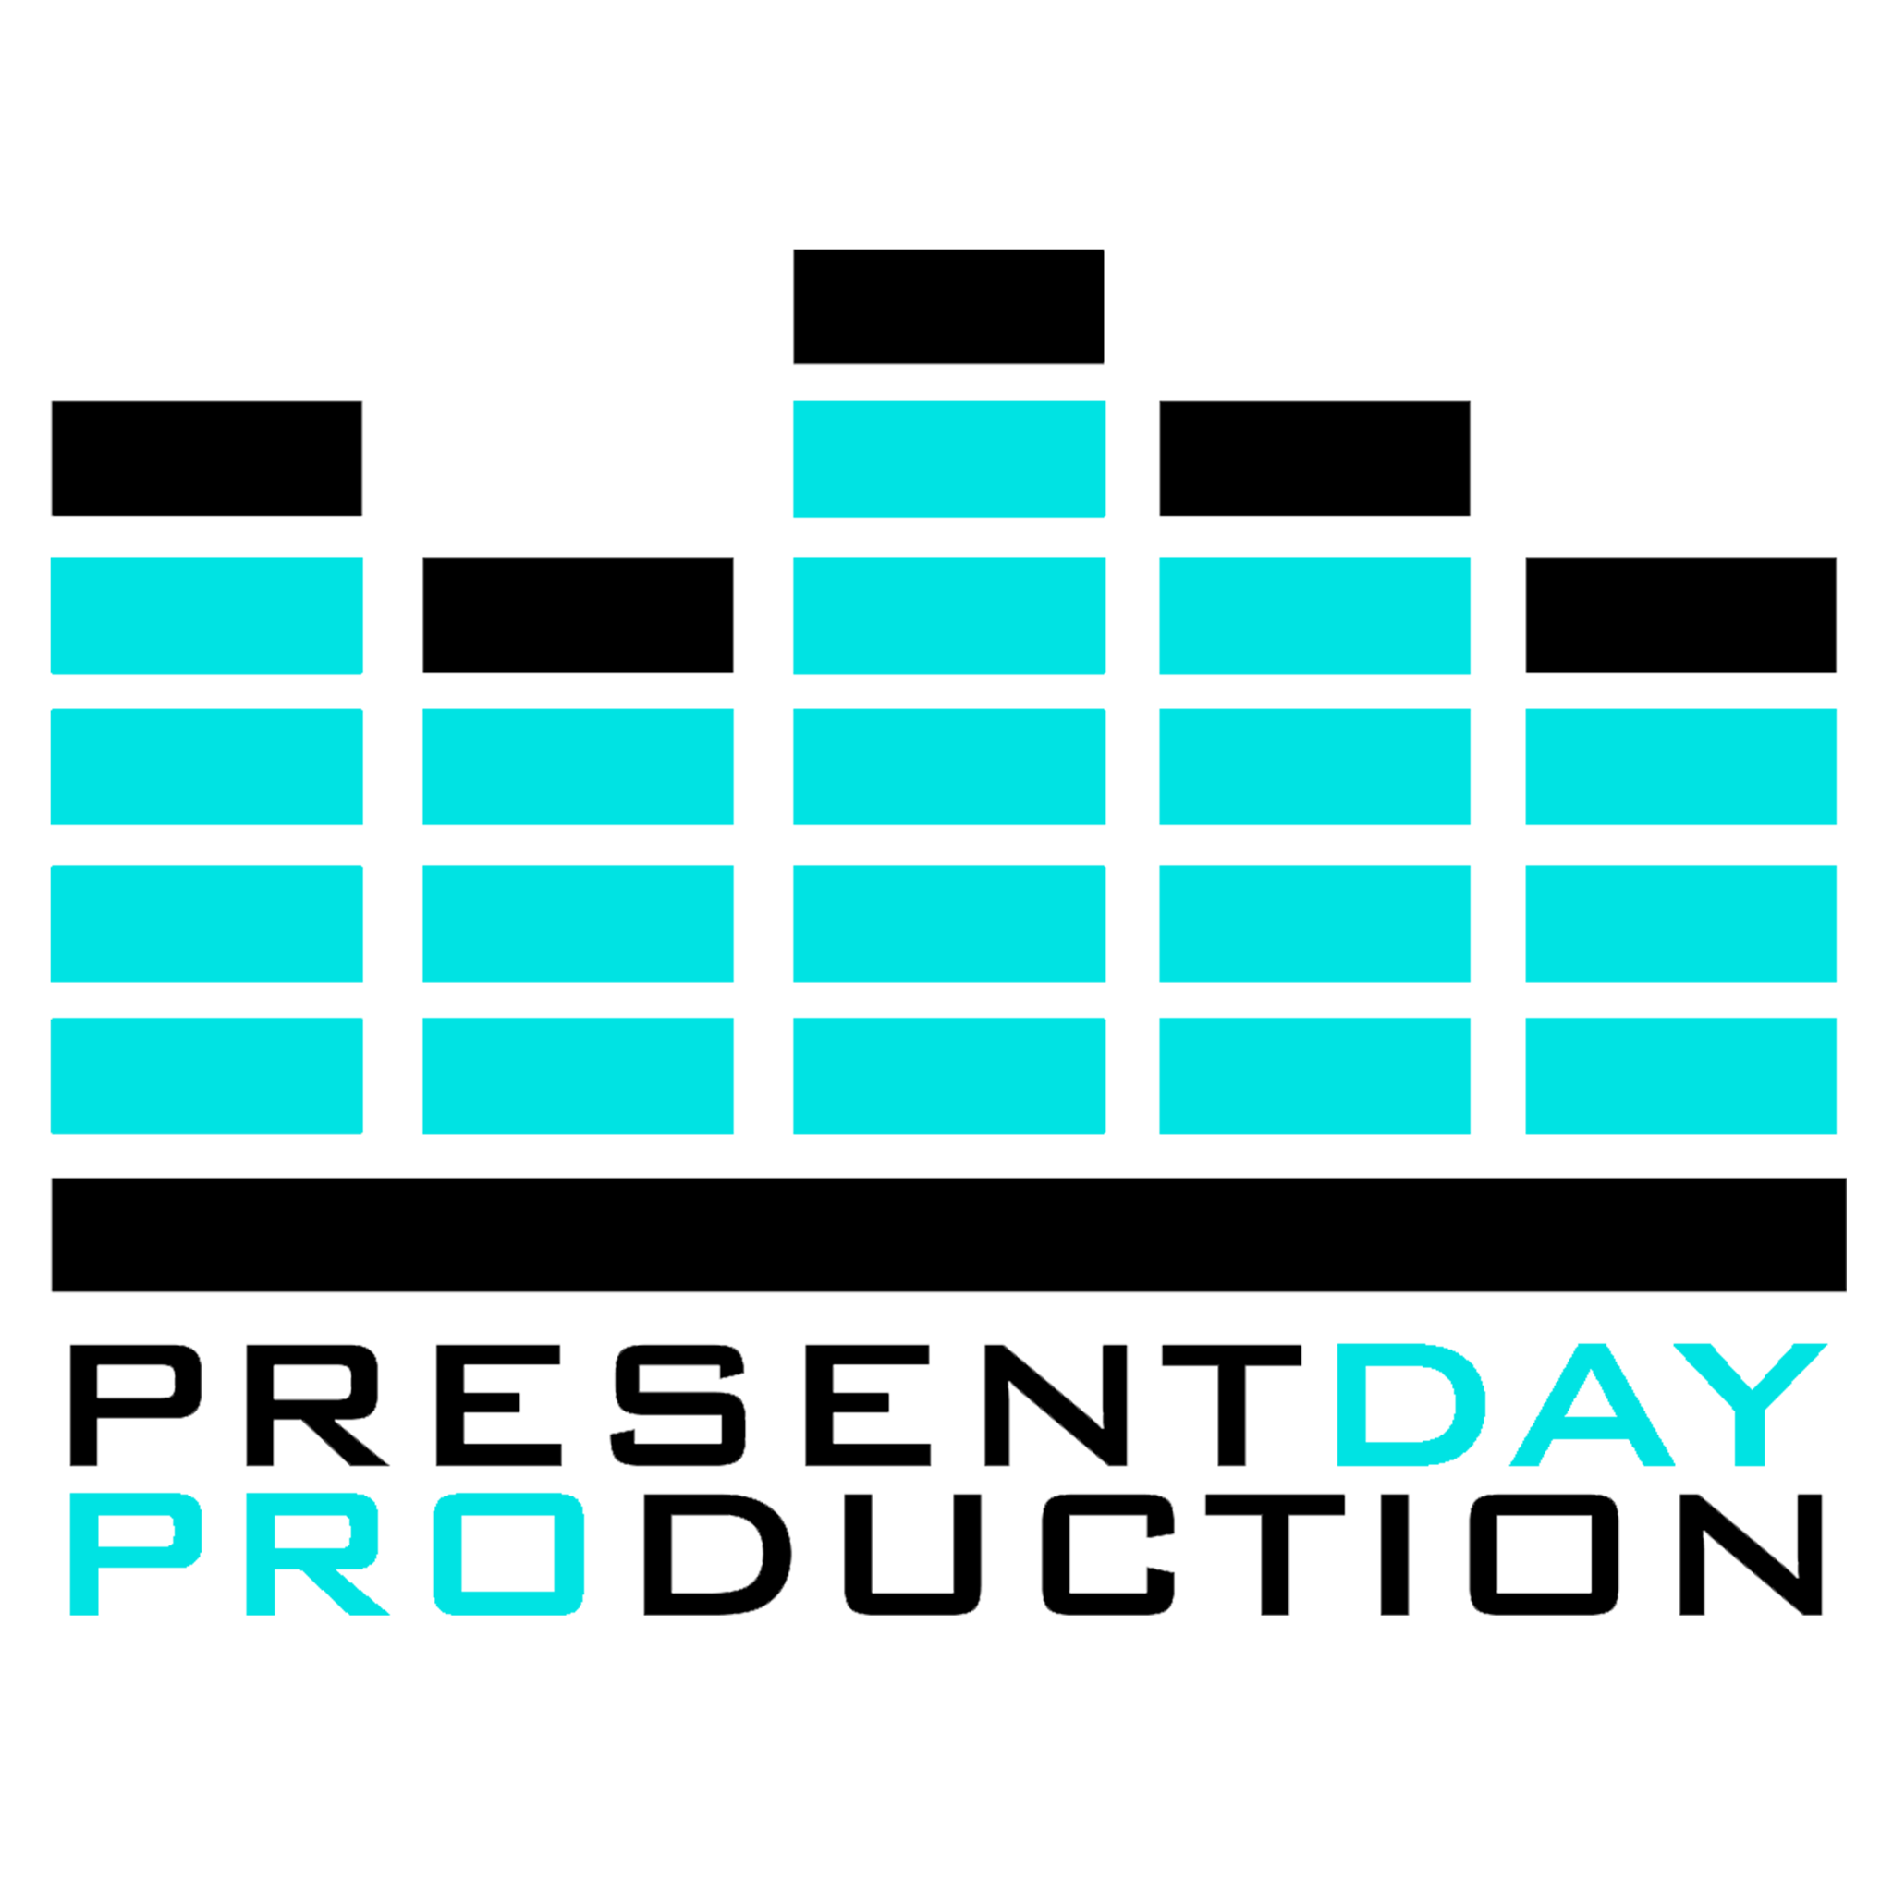

**Mutual Non-Disclosure Agreement**

Date:

Parties:

Cosmic Audio Ltd, a company registered in the United Kingdom under company number 09090005 whose registered office is at Unit 2, The Old Barn Works, Fluxs Lane, Epping, Essex, United Kingdom, CM16 7PE

and

[NAME OF INDIVIDUAL] of [address of individual]

OR

[NAME OF COMPANY], a company registered in [COUNTRY] whose registered office is at [ADDRESS]

1. Each of the parties to this Agreement intends to disclose information (the Confidential Information) to the other party for the purpose of [insert details e.g. discussing the possibility of the parties entering into a joint venture] (the Purpose).
2. Each party to this Agreement is referred to as ‘the Recipient’ when it receives or uses the Confidential Information disclosed by the other party.
3. The Recipient undertakes not to use the Confidential Information disclosed by the other party for any purpose except the Purpose, without first obtaining the written agreement of the other party.
4. The Recipient undertakes to keep the Confidential Information disclosed by the other party secure and not to disclose it to any third party except to its employees and professional advisers who need to know the same for the Purpose, who know they owe a duty of confidence to the other party and who are bound by obligations equivalent to those in clause 3 above and this clause 4.
5. The undertakings in clauses 3 and 4 above apply to all of the information disclosed by each of the parties to the other, regardless of the way or form in which it is disclosed or recorded but they do not apply to:  
     
    a) any information which is or in future comes into the public domain (unless as a result of the breach of this Agreement); or  
     
    b) any information which is already known to the Recipient and which was not subject to any obligation of confidence before it was disclosed to the Recipient by the other party.
6. Nothing in this Agreement will prevent the Recipient from making any disclosure of the Confidential Information required by law or by any competent authority.
7. The Recipient will, on request from the other party, return all copies and records of the Confidential Information disclosed by the other party to the Recipient and will not retain any copies or records of the Confidential Information disclosed by the other party.
8. Neither this Agreement nor the supply of any information grants the Recipient any licence, interest or right in respect of any intellectual property rights of the other party except the right to copy the Confidential Information disclosed by the other party solely for the Purpose.
9. The undertakings in clauses 3 and 4 will continue in force [indefinitely][for [insert number] years from the date of this Agreement].
10. This Agreement is governed by, and is to be construed in accordance with, English law. The English Courts will have non-exclusive jurisdiction to deal with any dispute which has arisen or may arise out of, or in connection with, this Agreement.

Signed [by [insert name]] OR [on behalf of][insert name] by its duly authorised representative]:

Signature

_________________________________________________________________________

Name

_________________________________________________________________________

Date

_________________________________________________________________________

Signed [by [insert name]] OR [on behalf of] [insert name] by its duly authorised representative]:

_________________________________________________________________________

Signature

_________________________________________________________________________

Name

Date

_________________________________________________________________________